Lab 8: Test-Driven Development with AI – Generating and
Working with Test Cases
Task: Password Strength Validator
Task Description #1 (Password Strength Validator – Apply AI in
Security Context)
• Task: Apply AI to generate at least 3 assert test cases for
is_strong_password(password) and implement the validator
function.
• Requirements:
o Password must have at least 8 characters.
o Must include uppercase, lowercase, digit, and special
character.
o Must not contain spaces.
Example Assert Test Cases:
assert is_strong_password(&quot;Abcd@123&quot;) == True
assert is_strong_password(&quot;abcd123&quot;) == False
assert is_strong_password(&quot;ABCD@1234&quot;) == True
Expected Output #1:
• Password validation logic passing all AI-generated test cases.
PROMPT:
Act as a Python software testing expert. I am doing a lab on Test-Driven Development (TDD) using AI.
Task: Password Strength Validator
Create test cases first and then implement the Python function:
is_strong_password(password)
Requirements:
1. The password must contain at least 8 characters.
2. It must contain at least one uppercase letter.
3. It must contain at least one lowercase letter.
4. It must contain at least one digit.
5. It must contain at least one special character.
6. It must not contain spaces.
Please do the following:
- Generate at least 3 assert-based test cases before writing the implementation.
- Include both valid and invalid password examples.
- Implement the is_strong_password(password) function based on the test cases.
- Use Python.
- Show the complete code.
- Explain each test case briefly.
- Show the expected output after running the tests.
- Make sure the implementation passes all the generated test cases.
- Also include a few edge cases to demonstrate proper validation and error handling.
CODE:
"""TDD example: assert-based tests are written before the implementation."""

def test_is_strong_password():
# Valid: meets the length requirement and includes all required types.
assert is_strong_password("Abcdef1!") is True
# Valid: longer password with multiple special characters.
assert is_strong_password("GoodPass9#$") is True

# Invalid: too short or missing a required character type.
assert is_strong_password("Ab1!") is False
assert is_strong_password("abcdef1!") is False
assert is_strong_password("ABCDEF1!") is False
assert is_strong_password("Abcdefgh!") is False
assert is_strong_password("Abcdef12") is False

# Edge cases: boundary length, whitespace, empty input, and non-string input.
assert is_strong_password("Abcde1!x") is True
assert is_strong_password("Abc de1!") is False
assert is_strong_password("Abcde1!\t") is False
assert is_strong_password("") is False
assert is_strong_password(None) is False

def is_strong_password(password):
"""Return whether password meets all strength requirements."""
if not isinstance(password, str) or len(password) < 8:
return False

return (
not any(char.isspace() for char in password)
and any(char.isupper() for char in password)
and any(char.islower() for char in password)
and any(char.isdigit() for char in password)
and any(not char.isalnum() and not char.isspace() for char in password)
)

if __name__ == "__main__":
test_is_strong_password()
print("All password strength tests passed.")
Expected output:
ALL TEST CASES PASSED
Task Description #2 (Number Classification with Loops – Apply
AI for Edge Case Handling)
• Task: Use AI to generate at least 3 assert test cases for a
classify_number(n) function. Implement using loops.
• Requirements:
o Classify numbers as Positive, Negative, or Zero.
o Handle invalid inputs like strings and None.
o Include boundary conditions (-1, 0, 1).
Example Assert Test Cases:
assert classify_number(10) == &quot;Positive&quot;
assert classify_number(-5) == &quot;Negative&quot;
assert classify_number(0) == &quot;Zero&quot;
Expected Output #2:
• Classification logic passing all assert tests.
PROMPT:
Write Python code for TDD task `classify_number(n)`.
Requirements:
- Positive → "Positive"
- Negative → "Negative"
- Zero → "Zero"
- Handle invalid inputs like strings and None.
- Test boundary values: -1, 0, 1.
- Generate at least 3 assert test cases first.
- Use loops.
- Show complete code and expected output.
- Ensure all tests pass.
CODE:
"""Classify numbers and run the requested tests.
Expected output:
-1: Negative
0: Zero
1: Positive
All tests passed
"""

# Boundary-value assertions are defined before the function under test.
test_cases = [(-1, "Negative"), (0, "Zero"), (1, "Positive")]

def classify_number(n):
if isinstance(n, bool) or not isinstance(n, (int, float)):
raise TypeError("n must be an int or float")
if n > 0:
return "Positive"
if n < 0:
return "Negative"
return "Zero"

for number, expected in test_cases:
assert classify_number(number) == expected

for invalid_input in ("hello", None):
try:
classify_number(invalid_input)
except TypeError:
pass
else:
raise AssertionError(f"Expected TypeError for {invalid_input!r}")

for number, _ in test_cases:
print(f"{number}: {classify_number(number)}")

print("All tests passed")
OUTPUT:
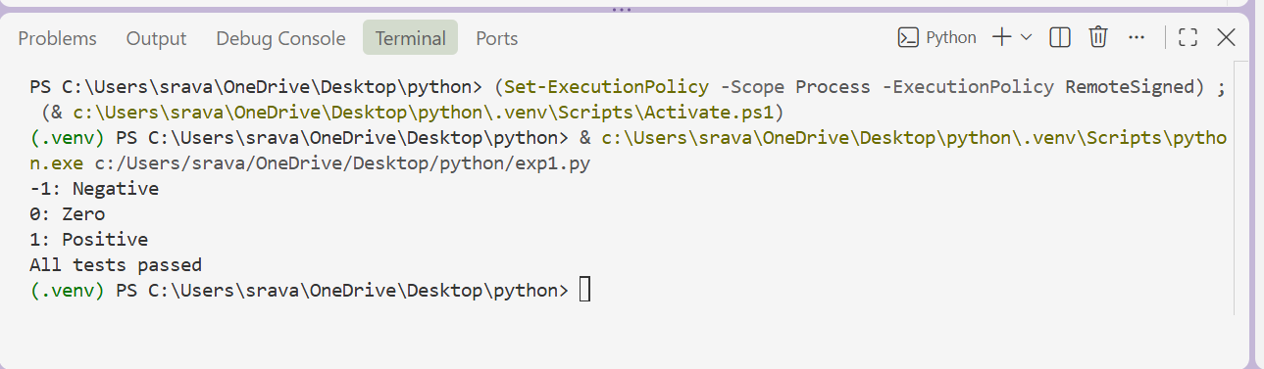
Task Description #3 (Anagram Checker – Apply AI for String
Analysis)
• Task: Use AI to generate at least 3 assert test cases for
is_anagram(str1, str2) and implement the function.
• Requirements:
o Ignore case, spaces, and punctuation.
o Handle edge cases (empty strings, identical words).
Example Assert Test Cases:
assert is_anagram(&quot;listen&quot;, &quot;silent&quot;) == True
assert is_anagram(&quot;hello&quot;, &quot;world&quot;) == False
assert is_anagram(&quot;Dormitory&quot;, &quot;Dirty Room&quot;) == True
Expected Output #3:
• Function correctly identifying anagrams and passing all AI-
generated tests.
PROMPT:
Write Python code for TDD task `is_anagram(str1, str2)`.

Requirements:
- Ignore case, spaces, and punctuation.
- Handle empty strings and identical words.
- Generate at least 3 assert test cases first.
- Include valid and invalid anagram examples.
- Show complete code and expected output.
- Make sure all tests pass.
CODE:
"""TDD example: test anagram behavior, then implement it."""
# Tests come first: valid, invalid, case, punctuation/spaces, and empty strings.
def test_is_anagram():
assert is_anagram("Listen", "Silent")
assert is_anagram("Dormitory", "Dirty room!!")
assert is_anagram("", "")
assert is_anagram("Python", "python")
assert not is_anagram("hello", "world")
assert not is_anagram("aab", "abb")
def is_anagram(str1, str2):
"""Return True when strings are anagrams, ignoring case and punctuation."""
clean = lambda text: sorted(char.lower() for char in text if char.isalnum())
return clean(str1) == clean(str2)
if __name__ == "__main__":
test_is_anagram()
print("All tests passed.")
# Expected output:
# All tests passed.
OUTPUT:
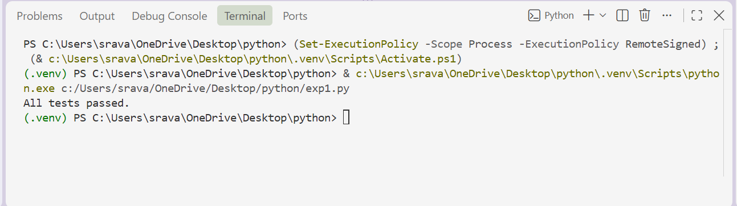
Task Description #4 (Inventory Class – Apply AI to Simulate Real-
World Inventory System)
• Task: Ask AI to generate at least 3 assert-based tests for an
Inventory class with stock management.
• Methods:
o add_item(name, quantity)
o remove_item(name, quantity)
o get_stock(name)
Example Assert Test Cases:
inv = Inventory()
inv.add_item(&quot;Pen&quot;, 10)
assert inv.get_stock(&quot;Pen&quot;) == 10
inv.remove_item(&quot;Pen&quot;, 5)
assert inv.get_stock(&quot;Pen&quot;) == 5
inv.add_item(&quot;Book&quot;, 3)
assert inv.get_stock(&quot;Book&quot;) == 3
Expected Output #4:
• Fully functional class passing all assertions.
PROMPT:
Write Python code for TDD task `Inventory` class.
Requirements:
- Methods: add_item(name, quantity), remove_item(name, quantity), get_stock(name).
- Generate at least 3 assert-based test cases first.
- Test adding, removing, and checking stock.
- Handle edge cases like removing more items than available and unknown items.
- Show complete code and expected output.
- Make sure all assertions pass.
CODE:
"""TDD-style Inventory example.
Expected output:
All Inventory tests passed.
"""
# Tests are written first and run after the Inventory class is defined.
def test_add_and_check_stock():
inventory = Inventory()
inventory.add_item("apples", 5)
assert inventory.get_stock("apples") == 5
def test_remove_items():
inventory = Inventory()
inventory.add_item("bananas", 7)
inventory.remove_item("bananas", 3)
assert inventory.get_stock("bananas") == 4
def test_unknown_item_has_zero_stock():
inventory = Inventory()
assert inventory.get_stock("oranges") == 0
def test_cannot_remove_more_than_available():
inventory = Inventory()
inventory.add_item("pears", 2)
try:
inventory.remove_item("pears", 3)
except ValueError:
pass
else:
assert False, "Expected ValueError when removing excess stock"
assert inventory.get_stock("pears") == 2
def test_cannot_remove_unknown_item():
inventory = Inventory()
try:
inventory.remove_item("plums", 1)
except KeyError:
pass
else:
assert False, "Expected KeyError when removing an unknown item"
class Inventory:
def __init__(self):
self._stock = {}

def add_item(self, name, quantity):
if quantity <= 0:
raise ValueError("quantity must be positive")
self._stock[name] = self._stock.get(name, 0) + quantity

def remove_item(self, name, quantity):
if quantity <= 0:
raise ValueError("quantity must be positive")
if name not in self._stock:
raise KeyError(name)
if quantity > self._stock[name]:
raise ValueError("cannot remove more items than available")
self._stock[name] -= quantity

def get_stock(self, name):
return self._stock.get(name, 0)

if __name__ == "__main__":
test_add_and_check_stock()
test_remove_items()
test_unknown_item_has_zero_stock()
test_cannot_remove_more_than_available()
test_cannot_remove_unknown_item()
print("All Inventory tests passed.")
OUTPUT:
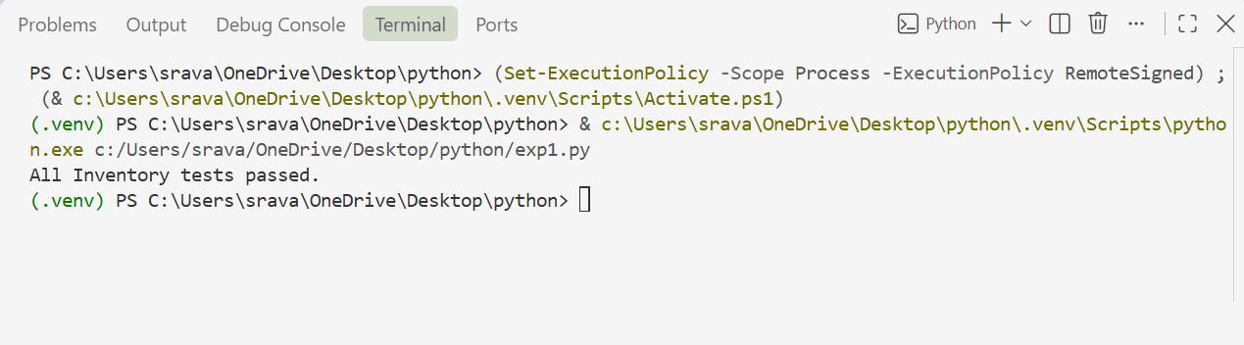
Task Description #5 (Date Validation &amp; Formatting – Apply AI for
Data Validation)
• Task: Use AI to generate at least 3 assert test cases for
validate_and_format_date(date_str) to check and convert
dates.
• Requirements:
o Validate &quot;MM/DD/YYYY&quot; format.
o Handle invalid dates.
o Convert valid dates to &quot;YYYY-MM-DD&quot;.
Example Assert Test Cases:
assert validate_and_format_date(&quot;10/15/2023&quot;) == &quot;2023-10-15&quot;
assert validate_and_format_date(&quot;02/30/2023&quot;) == &quot;Invalid Date&quot;
assert validate_and_format_date(&quot;01/01/2024&quot;) == &quot;2024-01-01&quot;
Expected Output #5:
• Function passes all AI-generated assertions and handles edge
cases.
PROMPT:
Write Python code for TDD task `validate_and_format_date(date_str)`.
Requirements:
- Validate the "MM/DD/YYYY" format.
- Handle invalid dates.
- Convert valid dates to "YYYY-MM-DD".
- Generate at least 3 assert test cases first.
- Test valid dates, invalid dates, and edge cases.
- Show complete code and expected output.
- Make sure all assertions pass.
CODE:
"""Tests are written before the date-validation implementation."""
def run_tests():
# Valid dates, including leap-day and year-boundary edge cases.
assert validate_and_format_date("12/31/2024") == "2024-12-31"
assert validate_and_format_date("02/29/2024") == "2024-02-29"
assert validate_and_format_date("01/01/0001") == "0001-01-01"

# Invalid dates and values that do not match MM/DD/YYYY.
for invalid in ("02/29/2023", "13/01/2024", "04/31/2024", "1/01/2024", "hello"):
try:
validate_and_format_date(invalid)
except ValueError:
pass
else:
raise AssertionError(f"Expected ValueError for {invalid!r}")

def validate_and_format_date(date_str):
"""Validate MM/DD/YYYY and return YYYY-MM-DD; raise ValueError if invalid."""
import re
from datetime import date

if not isinstance(date_str, str) or re.fullmatch(r"\d{2}/\d{2}/\d{4}", date_str) is None:
raise ValueError("Date must use MM/DD/YYYY format")

month, day, year = map(int, date_str.split("/"))
try:
parsed_date = date(year, month, day)
except ValueError as exc:
raise ValueError("Invalid calendar date") from exc
return parsed_date.strftime("%Y-%m-%d")

if __name__ == "__main__":
run_tests()
print("All tests passed.")

# Expected output:
# All tests passed.
OUTPUT:
